Additional files
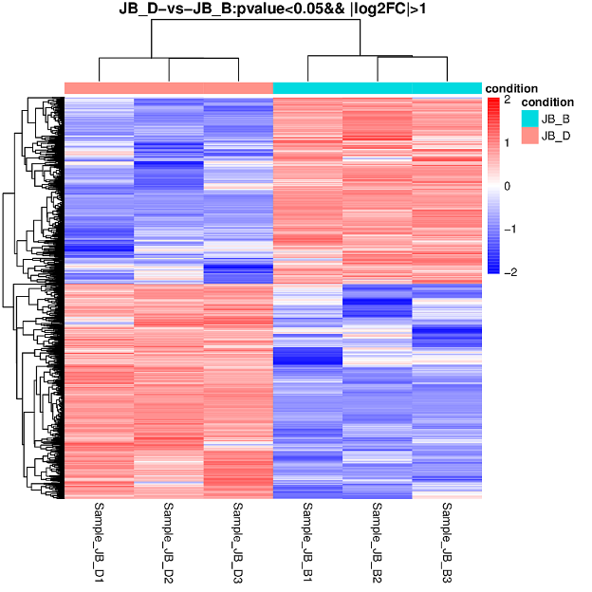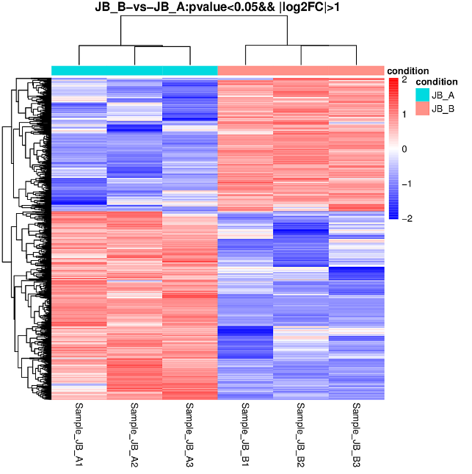
A
B
Fig. S1 Unsupervised hierarchical clustering was performed for differentially expressed genes. The distance between two pairs of multiple samples was calculated to form the distance matrix. The direct correlation of samples was calculated by the expression of selected differentially expressed genes, and the grouping cluster analysis chart was constructed. Red indicates the high expression gene and blue indicates the low expression protein coding gene.
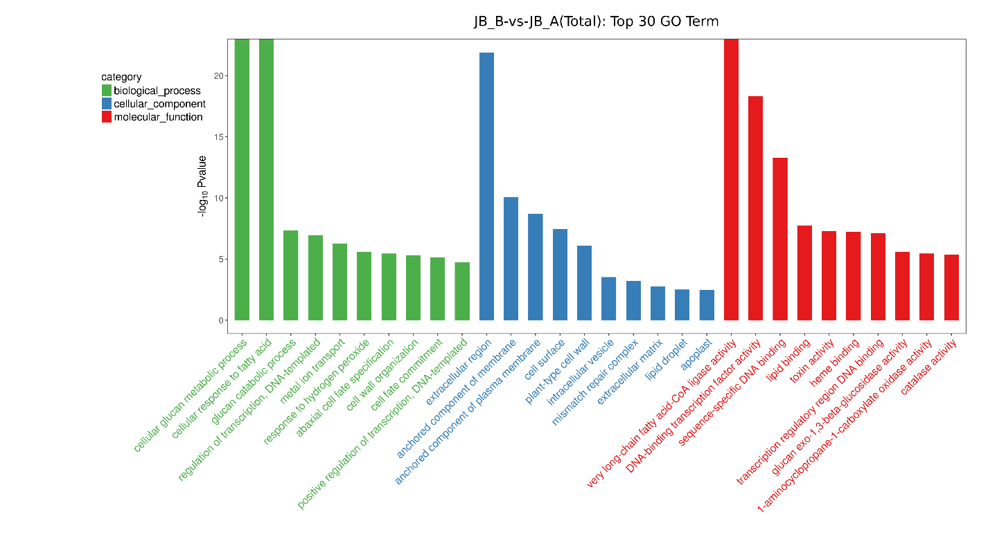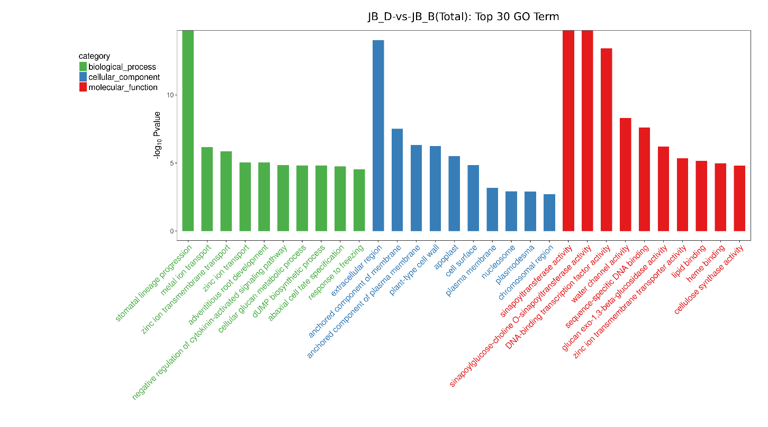
Fig. S2 The GO top30 analysis of JB_B vs. JB_A and JB_D vs. JB_B, respectively. Enrichment factor is the ratio of the DEGs to the background number in the given pathway.
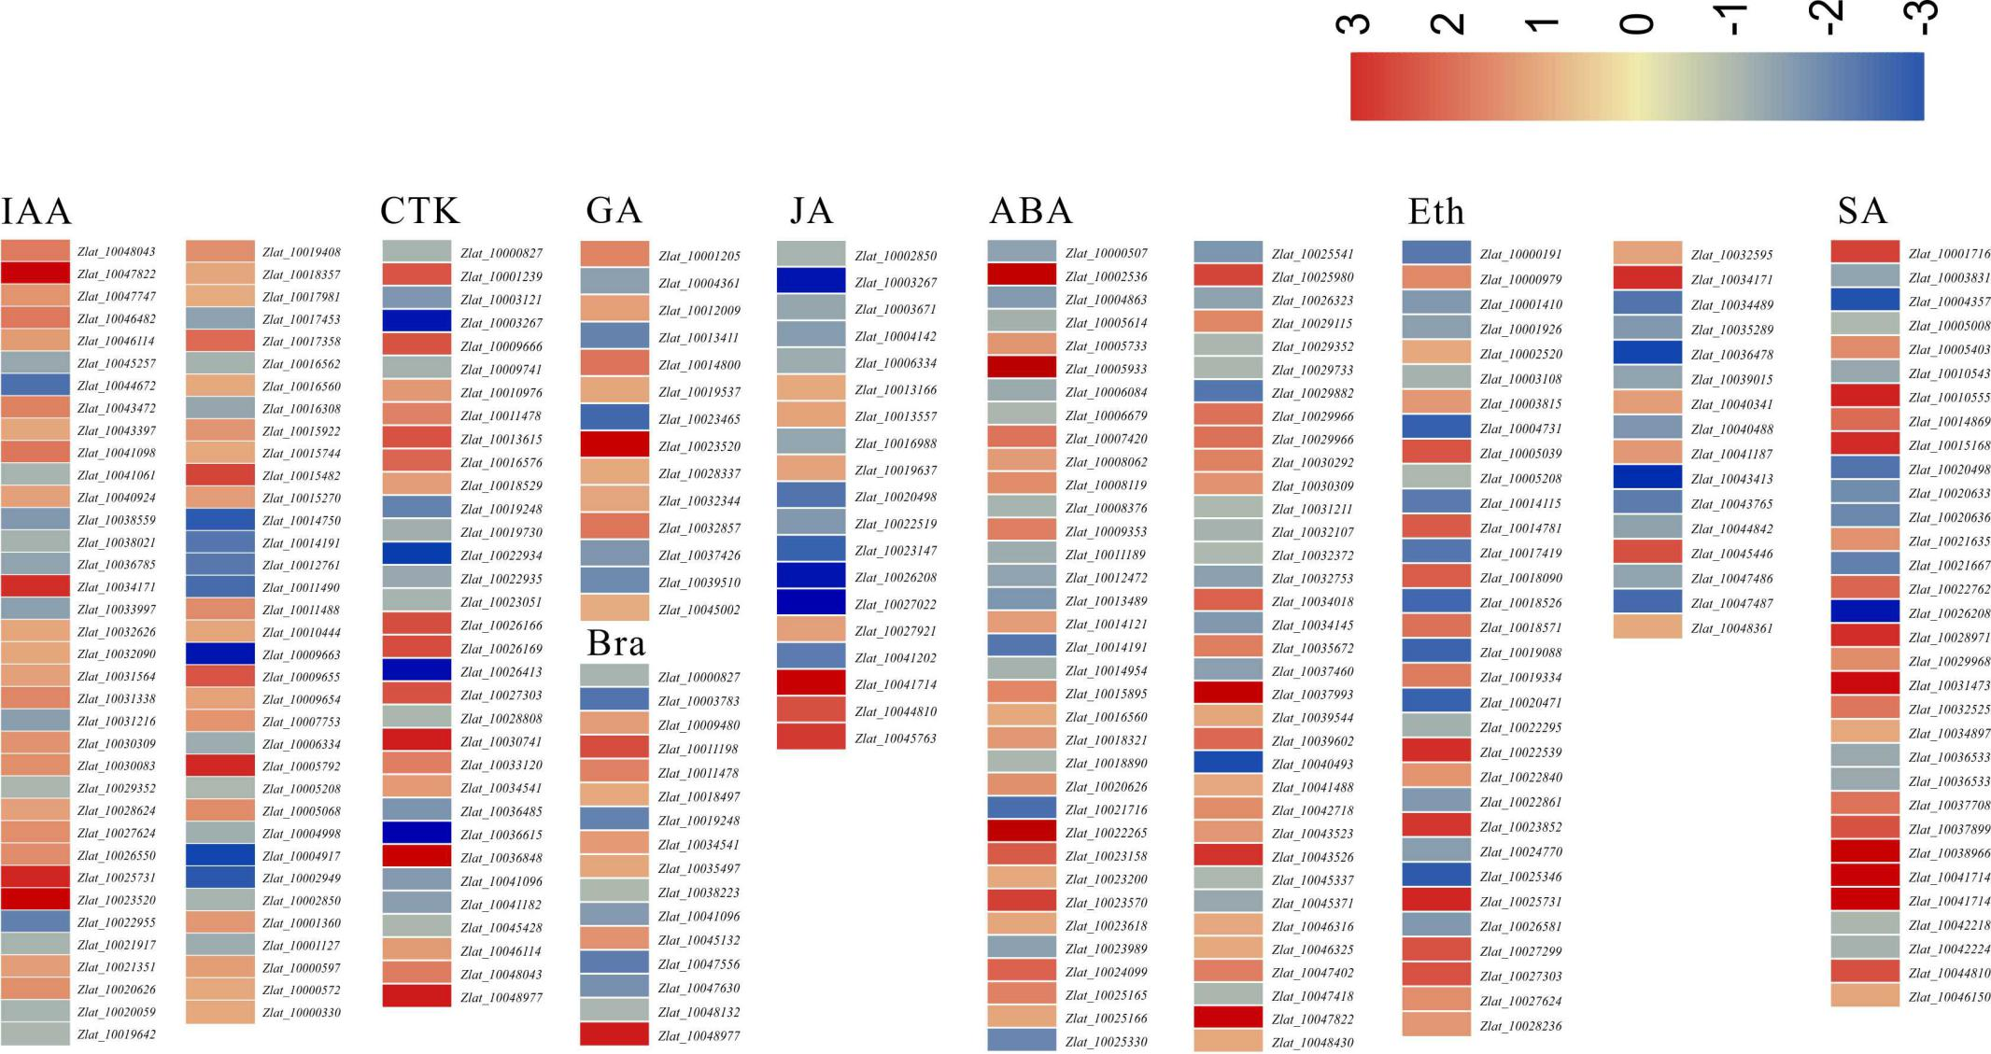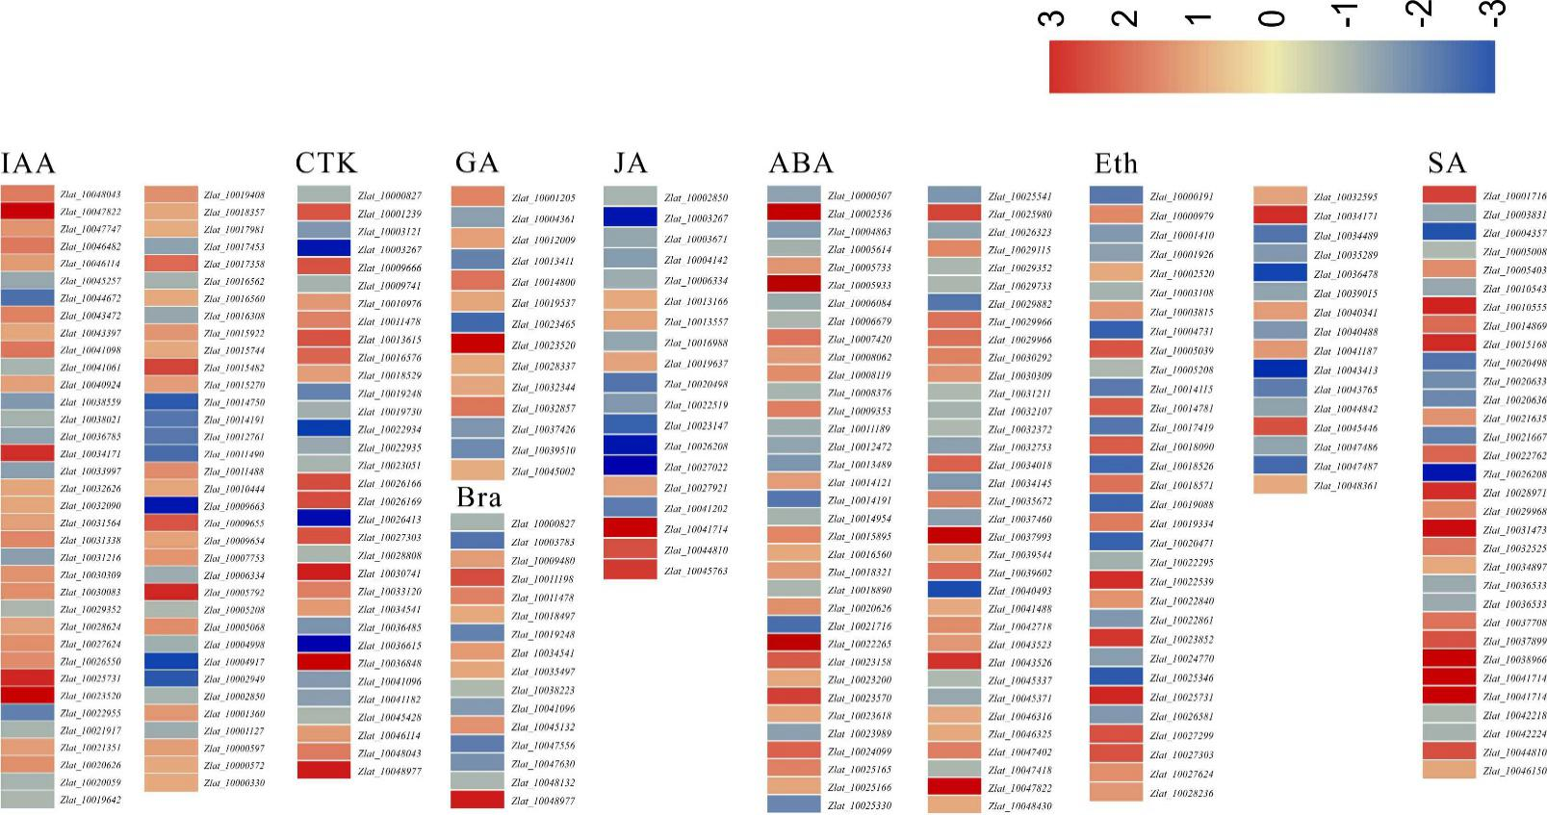
Fig. S3 The related plant hormone content DEGs was shown. We searched all DEGs data and analyzed all 8 related hormones (IAA, CTK, ABA, GA, SA, JA, Eth, Bra). All values were expressed by Log₂FC in JB_D vs. JB_B.

Fig. S4 Correlation of expression levels between RNA-seq and qRT-PCR that picked 18 JB_B VS JB_A and 17 JB_D VS JB_B, respectively. The log2 qRT-PCR (y-axis) was plotted against log2 RNA-seq (x-axis) of different treatment of before-after gall formation of Z. latifolia.

